***On Mission*** Support System

Generate Ministries

Generate Ministries, through the Strengthening Local Church area, helps churches stay on the mission God gave us to make disciples who make disciples. Here are some of the areas we help churches with:

* **Embracing the Mission of Jesus**. Looking at how Jesus made disciples to give us clues how to do this. Recapturing the idea of training and sending, not just preaching and teaching.
* **Changing What We Care About**. To stay ***On Mission*** requires several attitude shifts about the church and its people. We look at some of these, along with how we can best set an environment where God can transform minds, hearts and behavior.
* **Recognizing the Responsive.** Going off the four kinds of seeds Jesus talked about, we apply this to working with people: how can we connect with those seeking God, how do we help people discover the real Jesus, how can we help people grow as disciples of Jesus, and how do we mentor and train disciples to go into the harvest.
* **Intensifying Multiplication.** In ***On Mission*** we deal with two areas here: how do you change your church without blowing it up and how do we take the church to where the people are: apartments, neighborhoods, schools, business, hangouts, etc.
* **Unleashing Communities.** There are multiple approaches to going to the community, like multi-site (yes, even small churches), church planting, home groups, etc. There are also many kinds of expressions for doing this, like The Table Network, Xcellerate, Field USA, Real Life Discipleship, Missional Communities, etc. We help leaders in established churches see what might best fit their context and vision.

Here is some of the support system we can deliver:

* **Training**. Training events help people build awareness to new concepts. This training can take many different forms: weekend training events, one day training events, workshops at local churches on various topics, web training events for leaders, etc. Training can be customized to fit the timeframe and need. Our two main training events which touch on most of the ***On Mission*** topics are ***On Mission*** Basic and ***On Mission*** Advanced.
* **Pastor Clusters.** Monthly coaching events on video calls to encourage and equip pastors in various ***On Mission*** areas.
* **Coaching.** Individualized sessions for pastors to help them short term (3-6 months) work through a selected ***On Mission*** area.
* **ReMission.** Coaching for local church leadership teams. These sessions are a couple of hours monthly on site or by video call to help leadership teams work through the ***On Mission*** principles.

**Training Overview**

***Making Disciples Who Make Disciples***

***Who Make Disciples***

**Macintosh HD:Users:DanRemo:Desktop:OnMissionCycle-Causeways.pdf**Macintosh HD:Users:DanRemo:Desktop:OnMissionCycle-Causeways.pdf

“Jesus didn’t start services, He made disciples who made disciples.”

-- Dr. Dave DeVries



**Discuss in Church Groups:**

1. **What are your insights and reflections?**
2. **Where is your church strong?**
3. **Where does your church need to focus?**

**Changing What We Care About**

* ***Mindset change…***
* Alignment, not Assignment
* Disciples, not Decisions
* Being Church, not “Doing Church”
* Mission, not Maintenance
* Practices, not Programs
* Sending Capacity, not Seating Capacity
* People of God, not Place of God
* ***Knowing what a disciple is…***
* ***Biblical transformation process…***
* ***Teaching to obey…***

*.*

**Discipleship Cycle**

**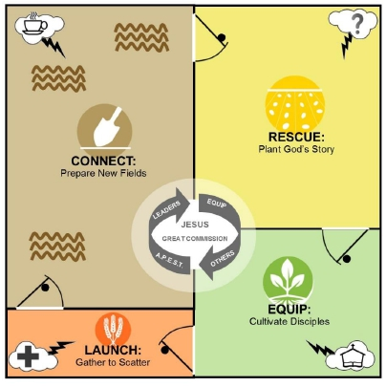***A way to follow Jesus and do the Great Commission that is holistic, practical and reproducible.*

***Life Groups***

**OUT**

**UP**

**IN**

***Spiritual Growth:***

***One Another’s;***

***30 Key Areas; Commands***

***of Jesus***

***Follow Up:***

***Bible,***

***Prayer,***

***Spiritual***

***Warfare***

***God’s Story***

***Discovery Groups***

***Stories of Hope***

***My Story***

***House of Peace***

***&***

***Person of Peace***

***Search***

***Proximity***

***& Presence***

***Prayer Walking***

***Spiritual Conversations***

***Serving & Compassion***

***Huddle: teaching & practicing skills***

***Multiplying***

***Groups***

**The Arts of Spiritual Conversations**

Qplace.com

***The 9 Arts of Spiritual Conversations.*** Mary Schaller & John Crilly

**Are you ready to learn how to have spiritual conversations?**

Like learning a musical instrument or improving at a sport, it doesn't happen overnight. It takes practice to get better. You'll find the best support in a community where you can learn from one another and stay on the journey together.

**Getting Ready:**

* ***The Art of Noticing:*** Noticing those around me and paying close attention to what God might be doing in their lives.
* ***The Art of Praying:*** Praying for those I meet in my day-to-day life and asking God to show me what he wants me to do to bless them.
* ***The Art of Listening:*** Listening with genuine care, interest, and empathy as I interact with others without editorializing or offering my own unsolicited opinions.

**Getting Started:**

* ***The Art of Asking Questions:*** Asking Questions that arise from genuine curiosity, drawing others out with great questions, seeking to understand more than to be understood.
* ***The Art of Loving:*** Loving others authentically because I personally know God's love and see them with his eyes.
* ***The Art of Welcoming:*** Welcoming people by valuing their presence so that they feel that they belong.

**Keeping it Going:**

* ***The Art of Facilitating:*** Facilitating good discussions in a group setting so that every person feels honored and respected, even when they believe differently from me.
* ***The Art of Serving Together:*** Serving together, gathering people to serve and know God and each other better through service.
* ***The Art of Sharing:*** Sharing my own story, learning others' stories, and expressing God's story of forgiveness through Jesus in a way that is respectful and meaningful.



**Living Out Our Faith: 30 Key Areas in our Christian Walk**

***Christian Life Profile. Randy Frazee.***

***Beliefs (transformed mind)***

1. **Trinity.** I believe the God of the Bible is the only true God—Father, Son and Holy Spirit.
2. **Salvation by Grace.** I believe a person comes into a right relationship with God by God’s Grace through  faith in Jesus Christ.
3. **Authority of the Bible.** I believe the Bible is the Word of God and has the right to command my belief  and action.
4. **Personal God.** I believe God is involved in and cares about my daily life.
5. **Identity in Christ**. I believe I am significant because of my position as a child of God.
6. **Church**. I believe the church is God’s primary way to accomplish his purposes on earth today.
7. **Humanity**. I believe all people are loved by God and need Jesus Christ as their Savior.
8. **Compassion**. I believe God calls all Christians to show compassion to those in need.
9. **Eternity**. I believe there is a heaven and a hell, and I believe Jesus Christ is returning to judge the earth  and establish his eternal kingdom.
10. **Stewardship**. I believe everything I am or own belongs to God.

***Virtues (transformed heart)***

1. **Love**. I sacrificially and unconditionally love and forgive others.
2. **Joy**. I have inner contentment and purpose in spite of my circumstances.
3. **Peace**. I am free from anxiety because things are right between God, myself, and others.
4. **Patience**. I take a long time to overheat, and I endure patiently the unavoidable pressures of life.
5. **Kindness/Goodness**. I choose to do the right things in my relationships with others.
6. **Faithfulness**. I have established a good name with God and with others based on my long-term loyalty to  that relationship.
7. **Gentleness**. I am thoughtful, considerate, and calm in dealing with others.
8. **Self-Control**. I have power, through Christ, to control myself.
9. **Hope**. I can cope with the hardships of life and death because of the hope I have in Jesus Christ.
10. **Humility**. I choose to esteem others above myself.

***Practices (transformed behavior)***

1. **Worship**. I worship God for who he is and what he has done for me.
2. **Prayer**. I pray to God to know him, to lay my requests before him, and to find direction for my daily life.
3. **Bible Study**. I study the Bible to know God, the truth, and to find direction for my daily life.
4. **Single-mindedness**. I focus on God and his priorities for my life.
5. **Biblical Community**. I fellowship with other Christians to accomplish God’s purposes in my life, others’ lives,  and in the world.
6. **Spiritual Gifts**. I know and use my spiritual gifts to fulfill God’s purposes.
7. **Giving Away My Time**. I give away my time to fulfill God’s purposes.
8. **Giving Away My Money**. I give away my money to fulfill God’s purposes.
9. **Giving Away My Faith.** I give away my faith to fulfill God’s purposes.
10. **Giving Away My Life**. I give away my life to fulfill God’s purposes.

***A Disciple Making Huddle***

Key characteristics of a

Disciple Making Missional Community:

* **Checking In** *(encouragement and accountability questions)*

The triangle becomes the basis for this: Up, In, Out *(Connecting with God, Connecting with Each Other, Connecting with the Community).*

* **Caring** *(sharing, prayer, meeting needs of each other)*
* **Discovery** *(discussing the Bible, asking the “so what?” and “now what?” questions so we obey the scriptures. Checking how we are living out previous “now what” discoveries)*
* **Serving** *(living out our faith in the community by serving together)*
* **Skills** *(learning how to have spiritual conversations and start “discovery groups” with pre-Christians; plan of salvation; follow up plans; stories of hope; telling “my story;” finding persons of peace, etc.)*
* **Multiplication** *(each member or couple strives to form their own disciple making group modeled after this one beginning with a “person of peace”)*

*Suggestion:* To not overload people, the main group could meet every two weeks, with the multiplied group meeting in the off weeks. Each member or couple stays in the main group and meets with their group, striving to do the same multiplication with their group. A group could be with just one other individual.

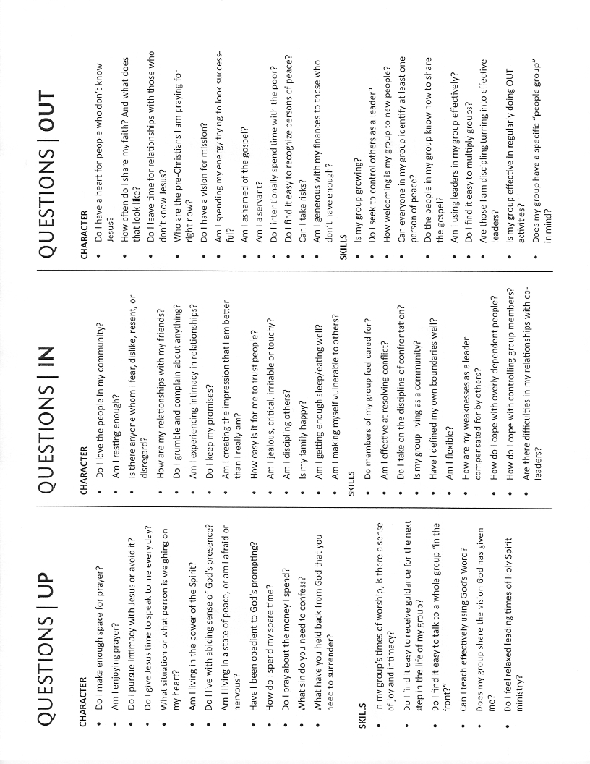

**Discipleship Monthly Report**

**Personal:**

1. How are you doing?
2. How can we assist and pray for you?
3. What problems or issues are you facing?

**Progress:**

* *Which of the following activities were you involved in this month?*

1. Establishing new contacts which could lead to meaningful relationships.
2. Blessing your community through acts of love and service.
3. Sharing the gospel with unbelievers.
4. Discipling believers.
5. Training others in disciple-making ministry.
6. Coaching others in disciple-making ministry.
7. Providing administrative services which facilitate discipleship multiplication.
8. Other activities.

* New contacts: List names and comments.
* Recurring contacts: List names and comments. *These are follow up contacts you feel are developing into an ongoing relationship.*
* Significant conversations: List names and comments. *These include conversations that move beyond sports or the weather to serious life issues.*
* Opportunities to share the gospel: List names and comments.
* New people being disciples: List names and comments.
* Disciples in process: List names and comments.
* Disciples being made by your disciples: List names and comments.
* Baptisms this month: List names and comments.
* New Faith Communities formed: List locations and comments. *These include any regular gathering where Christian community is practiced.*
* What are your discipleship plans for the coming month?

**Changing Your Church *(Without Blowing it Up)***

***Dan Riemenschneider***

**Introduction**

* Question: What are some changes facing you as you are seeking to multiply a movement?
* Why is this important?
* *Getting back to biblical values that we have lost along the way.*
* *Bringing people along with you without killing the movement.*
* Change process follows a similar pattern to the disciple making life transformation process.
* *Transformed Mind*
* *Transformed Heart*
* *Transformed Behavior*

**Measures of Change**

* **Unawareness**
* *Mistake: assuming people know what needs to happen.*
* **Awareness** *(changed mind)*
* *Mistake: assuming when people reach this level they are ready to implement.*
* **Embracing** *(changed heart)*
* *Mistake: assuming people know how to make the change happen.*
* **Implementation—putting into practice** *(changed behavior)*
* *Mistake: assuming you will not encounter difficulty*
* *Mistake: assuming results will come quickly.*
* **Effectiveness—results**
* *Mistake: assuming you have arrived.*

**Process of Change**

* Moving from unawareness to awareness: ***educate***
* Moving from awareness to embracing: ***enlighten***
* Moving from embracing to implementation: ***equip***
* Moving from implemention to effectiveness: ***encourage***

**Key points to remember:**

1. Next five years are going to go by anyway. Take small steps, but take them.
2. Not everyone will move forward at the same pace.
3. Some may not move forward at all.
4. When working with a group, it is not necessary to have 100% buy-in to move forward, but it is necessary to have 100% buy-in from the key influencers in the group.

**One Mission. Multiple Expressions.**

1. **Similarities Between Expressions**

* *Embrace the Mission of Jesus*
* Disciple making is for everyone
* We are to be the church, not just go to church
* Starting small
* Making disciples the way Jesus made disciples (the Words and Ways of Jesus)
* Power of the Spirit for guidance
* It’s about making disciples, not planting churches
* *Changing What You Care About*
* Discipleship vs. Disinfection
* People vs. Events
* Proximity and Presence vs. Programs
* Multiplication vs. Addition
* Creating tension vs. giving all the answers
* Living the Bible vs. Bible studies
* Reaching messed up people vs. religious people
* *Spiritual Conversations*
* *Gathering and Scattering*
* *Initial Training Framework*
* **Xcellerate:** introduction to xcellerate process
* **Table Network:** introduction to concepts of Freedom, Family and Living in Three Spaces
* **Field USA:** introduction to Three-Thirds Process and Discipleship Cycle
* **On Mission:** raising the spiritual temperature of the established church

1. **Primary Focus of Each Expression**

* **Xcellerate:** conventional church planting; structured xcellerate gatherings
* **Table Network:** missional communities; reproducible leadership guides; cohorts for coaching and implementation
* **Field USA:** Organic house gatherings; disciple making tools; structured gathering
* **On Mission:** established churches; tools for raising the spiritual temperature of the church; tools for developing leaders

1. **Unique Advanced Training Areas**

* **Xcellerate:** church planting; diagnostic icons
* **Table Network:** reaching the 70% who will not attend any kind of established gathering or church; Living in 3 Spaces; Freedom and Family
* **Field USA:** Three-Thirds Process; Creating a gathering from scattering; T4T advanced topics
* **On Mission:** changing your church without blowing it up

**Topics for Training and Coaching**

1. **Creating a Disciple Making Environment** *(mission, mindset, raising the spiritual temperature of the church)*
2. **Disciple Making Skills**

* Finding a Person of Peace
* Serving & Compassion
* Spiritual Conversations
* Proximity & Presence
* Launching Discovery Groups
* Stories of Hope
* Telling “my” Story
* Telling God’s Story
* Multiplying Disciple Making Huddles
* New Believers Follow Up
* Creating a Spiritual Growth Plan

1. **Finding, Mentoring and Developing Leaders**
2. **Turning Traditional Small Groups into Disciple Making Groups**
3. **Changing Your Church Without Blowing it Up**
4. **Understanding Your Church & Community Culture**
5. **Creating and Living Out Kingdom Values**
6. **APEST Role**